**MINOR-1 PROJECT**

**SYNOPSIS REPORT**

For

Heart Attack Detector: An IoT based solution integrated with cloud

Submitted By

|  |  |  |
| --- | --- | --- |
| **Specialization** | **SAP ID** | **Name** |
|  |  |  |
|  |  |  |
|  |  |  |



Department of Systemics

School Of Computer Science

UNIVERSITY OF PETROLEUM & ENERGY STUDIES,

DEHRADUN- 248007. Uttarakhand

Ms. Avita Katal Dr. Neelu J. Ahuja

**Project Guide Cluster Head**



**School of Computer Science**

University of Petroleum & Energy Studies, Dehradun

**Synopsis Report**

**1. Project Title**

Heart Attack Detector: An IoT based solution integrated with cloud

**2. Abstract**

Heart rate monitoring is a vital aspect of maintaining heart health. People from different age groups have different ranges for maximum and minimum values of heart rate, the monitoring system must be compatible enough to handle this scenario. For the same purpose, an IoT-based solution has been developed that can monitor the heartbeat based on the output of a hardware system comprised of a pulse sensor. Further, an alert call system is added which is activated if the heartbeat falls below or exceeds above the permissible level given in the devised algorithm. The call is received by the doctor or caretaker of the patient. By using this prototype the doctors can access the heartbeat data of the patient. The nurses or the duty doctor available at the hospital can monitor the heart rate of the patient through the real-time monitoring system. The heartbeat data and other personal details of the patient are stored in the cloud, this can be utilized for future studies on the health condition of the patient.

**3. Introduction**

Nowadays, health issues such as cardiac failure, lung failure, and heart-related diseases are on the rise at an alarming rate. Because of these issues, regular health monitoring is essential. Wireless health monitoring of a patient is a modern concept. It is a significant advancement in the medical field. Using leading technologies such as wireless communications, wearable and portable remote health monitoring devices, health professionals have developed a brilliant and inexpensive health monitoring system for providing more comfortable living to people suffering from various diseases. As information about the patient's health directly reaches the doctor's monitor screen from anywhere the patient resides, doctor visits to patients are constantly decreasing. Furthermore, based on this, doctors can save many lives by providing them with a timely and valuable service. Because of technological advancements in the field of medical science, it has become much easier to determine different parameters of a patient using electronic machines, such as heart rate, temperature, and so on. Heart rate monitoring System is one such electronic device.

Nowadays, health issues such as cardiac failure, lung failure, and heart-related diseases are on the rise at an alarming rate. Because of these issues, regular health monitoring is essential. Wireless health monitoring of a patient is a modern concept. It is a significant advancement in the medical field. Using leading technologies such as wireless communications, wearable and portable remote health monitoring devices, health professionals have developed a brilliant and inexpensive health monitoring system for providing more comfortable living to people suffering from various diseases. As information about the patient's health directly reaches the doctor's monitor screen from anywhere the patient resides, doctor visits to patients are constantly decreasing. Furthermore, based on this, doctors can save many lives by providing them with a timely and valuable service. Because of technological advancements in the field of medical science, it has become much easier to determine different parameters of a patient using electronic machines, such as heart rate, temperature, and so on. Heart rate monitoring System is one such electronic device. According to the 2014 Survey of Sample Registration System (SRS) in Indonesia, Coronary Heart Disease (CHD) is the second leading cause of death at all ages after stroke, accounting for 12.9 percent of all deaths. Because heart attacks are usually detected using special hardware and performed in hospitals, the cause of death is delayed detection. IOT (Internet of Things) technology has recently emerged as one of the technologies with the concept of an object being able to transfer data over a network without the need for human-to-human or human-to-machine interaction. The Internet of Things (IOT) emerged from the convergence of wireless technologies, micro electromechanical systems (MEMS), and the Internet. In this project, the heart attack detection system is proposed which is able to monitor the heart rate using the health heart rate sensor. A sim module is interfaced with the microcontroller in order to trigger a call when there is an abnormal activity captured by heart sensor. The data is stored in the firebase so that doctor can able to access the stored data to monitor the person.

**4. Literature Review**

Several heap managers have been developed to enhance the performance of allocators in multithreaded settings.

The authors of [1] developed an IoT based heart rate monitoring system using Raspberry Pi not just as a sensor node but also a controller. The heart rate of the patient can be monitored by the doctor or by the guardian without actually visiting the patient.

The authors in [2] describes a technique of measuring the heart rate through a fingertip and show the heart beat on LCD and display the results over the net using local server as well as globally over Thingspeak site.

The authors in [3] implementing heart rate monitoring and heart attack recognition system using IoT. The patient will carry hardware having sensors with android application. The heartbeat sensor will allow checking heart beat readings and transmit them over the internet. The user may set the high and low level of heartbeat limits.

**5. Problem Statement**

Many people have recently become more concerned about abrupt cardiac arrest. With the growing popularity of smart wearable devices, the possibility of providing an Internet of Things (IoT) solution has increased. The Heart Rate Monitoring system using IOT with an objective of detecting the heartbeat of the patient in order to monitor the risk of heart attack and also the regular check-up is developed.

**6. Objectives**

* To monitor the heartbeat of the patient and checks if there is any unusual behaviour or not.
* To trigger a call to the caretaker or the doctor if there is any abnormal behaviour in the heartbeat of the person.
* To store the information in the cloud so that doctors and caretakers can access the data.

**7. Methodology**

* Pulse sensor is interfaced with ESP8266 microcontroller to get the heart rate of the patient.
* The recordings of the heart rate along with patient ID is stored in database so that doctor can check the recordings without vising the patient.
* A sim module is integrated with the system so that an alert call is triggered to the care taker when there is an abormal behaviour seen during the data capture.
* A front end website will be developed to extract the data from the database for particular patient.

**8. PERT Chart**

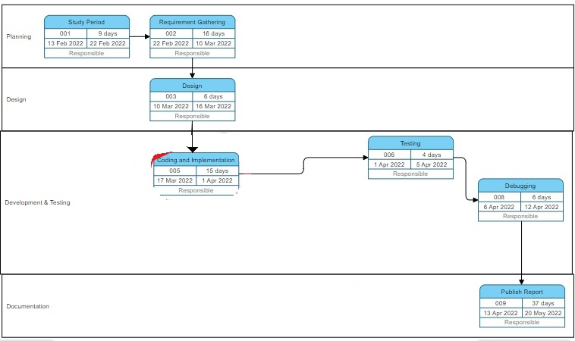

**9. Results**

Two web applications are built using Java Swing that is one for patient admin and other doctor to monitor the heart beat of the patient. In patient web application the dial button is integrated for calling in case of abnormal behaviour shown by BPM. The figures below shows the BPM of the patient in doctor panel and in patient panel.

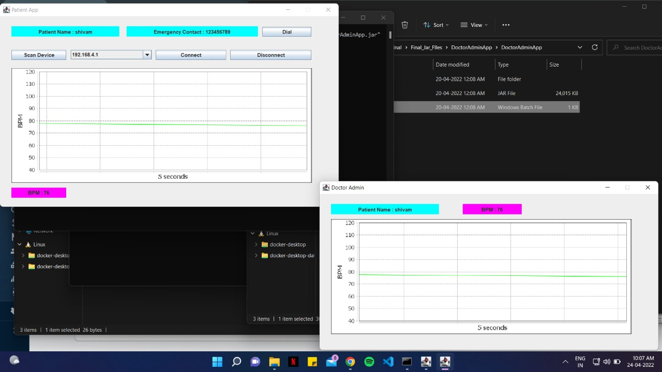

Patient web application Doctor web application

An android application is also developed for doctor. Doctor should register before checking the heart beat of the patient. Once he is registered, he can login with his details and check the BPM of the patient. Figure below shows the interface of the android application.

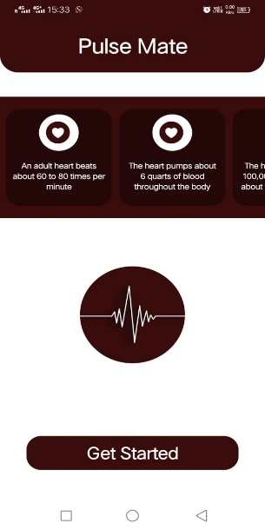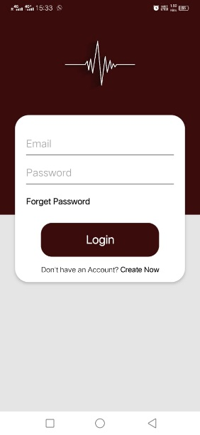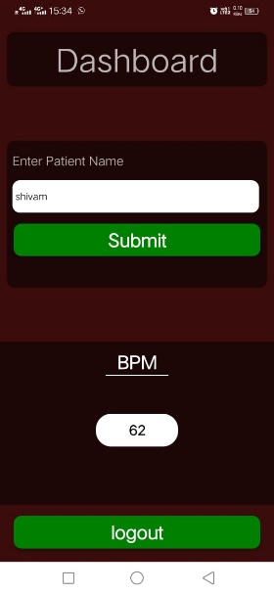

Doctor Android Application

**10. References**

[1] I. Journal, S. S. Kazi, G. Bajantri, and T. Thite, “Remote Heart Rate Monitoring System Using IoT,” International Research Journal of Engineering and Technology, 2018, Accessed: Mar. 14, 2022. [Online]. Available: www.irjet.net

[2] V. Goel, S. Srivastava, D. Pandit, D. Tripathi, and P. Goell, “Heart Rate Monitoring System Using Finger Tip through IOT,” International Research Journal of Engineering and Technology, Accessed: Mar. 14, 2022. [Online]. Available: www.irjet.net

[3] N. Patel and P. Patel, “Heart Attack Detection and Heart Rate Monitoring Using IoT,” Nehal Patel International Journal of Innovations & Advancement in Computer Science, 2018, Accessed: Mar. 14, 2022. [Online]. Available: https://www.researchgate.net/publication/329268152

**11. GitHub Link**

<https://github.com/viteshsethi18/Heart-Rate-Minor-2>